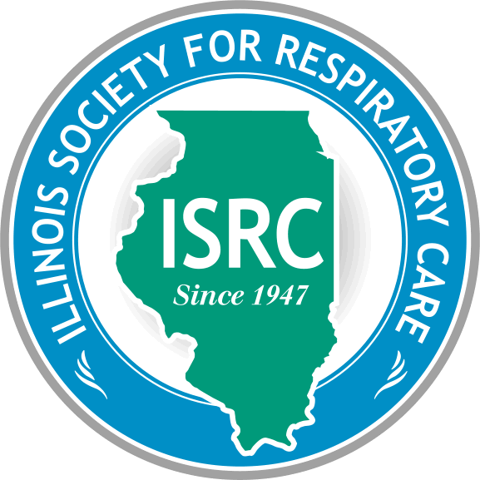
ILLINOIS SOCIETY FOR RESPIRATORY CARE

Affiliate of AARC
Administrative Office: P.O. Box 10261-Springfield, IL 62791
(217) 522-5558- FAX (217) 522-5557

Board of Directors
Second Quarter Meeting Minutes
October 19, 2022

- Steve Mosakowski called the meeting to order.

- Roll call taken via Zoom chat – quorum not present. Jacki Moss will be typing up the recorded meeting

President – Steve Mosakowski | P | Chapter 1 Chair – John Sloam | E | Chapter 1 Rep - Open | _
President Elect – Anne Geistkemper | P | Chapter 2 Chair – Katie Dugan | P | Chapter 2 Rep – Sara Murphy | P
VP– Midge Seim | E | Chapter 3 Chair – Sarah Higar | A | Chapter 3 Rep - Open | _
Secretary – Jacki Moss | E | Chapter 4 Chair – Aaron Brace | A | Chapter 4 Rep – Open | _
Treasurer – Gina Hoots | P | Chapter 5 Chair – Lori Badgley | P | Chapter 5 Rep – Kristin King | P
Delegate – Lexi Caraway | P | Chapter 6 Chair – Debbie Booton | A | Chapter 6 Rep – Open | _
Alt. Delegate – Molly Marin | P | Administrator - Maureen Mulhall | P
P=Present A=Absent E=Excused (10 need to be present if all positions are filled to make a quorum)
- Introduction/Induction of any new BOD members – none

- Welcome Guests, Recognize and Kudos
Thank you to all of the RTs who have helped with Hurricane Ian.
- First Quarter BOD meeting minutes
Correction needed – Title should state “First” Quarterly meeting
- Treasurer’s Report – Gina Hoots
AARC deposit for membership - $2,482,52
Card balance - $524
Bank balance - $8,000

- Fiscal responsibility, budget, and audit
No report

- Membership – Midge (copied from submitted report)
The current ISRC membership is at 996 members in all categories. In the past five years we have seen our membership decline by over 400 members.

I would also like to heartily encourage a return to a live-in-person conference. Although the number of attendees had dropped some. It was quite common to have 100+ new memberships and renewals. I think that we are seeing a large number of non-renewals and lapsed memberships. The vendor hall and social-networking that were a part of the conference experience also presented a convenient method of reminding attendees to renew their memberships. I fear that we have been “out-of-sight” and out of mind.
If there are others who would like to work with me to develop a message to increase active membership, please email me: mseim@parkland.edu or call 217.493.0787.

- Delegate’s Report – Senior Delegate: Lexi Caraway
Getting prepared for the winter meeting in New Orleans

- Acceptance of Treasurer and Delegate Reports—Steve Mosakowski
Quorum is not present

- Legislative/Governmental Affairs - Robin and Lisa. Matt and Maureen
It is very important to establish relationships with legislators who may not know what RTs do now more than ever. In the last two years, most of the communication has been virtually due to Covid and there has been a significant turnover of our legislators.

Training to all board members will be offered by Matt and Maureen and will consist of how a bill becomes a law, and how and why to communicate with our legislators. Theis free virtual training will be 60 minutes and will be scheduled no later than the end of January.
Matt and Maureen will get the updated legislator contact information to us as well as dates they are available for the training. Steve will send out survey asking for BOD members availability.
- Council Reports
Executive Council (Steve Mosakowski - President)
- Administrative Report – Maureen Mulhall, ISRC Administrator
Nothing additional from above

- Legislative Report - Matt Maloney
Matt thinks the sunset of our license may be more difficult because Legislators are wanting to know how professional licensure adds to public safety.

- Website – Update – Anne
Send all information and pictures of Respiratory Care week to Anne so it can be posted on the website.
Looking into event registration possibilities
Need to know all of the IL activities and speaking engagements taking place
A great piece would be an RT’s experience helping with Ian

- Summit Award – Lexi Caraway
Collecting information
Will work with Jacki to get BOD meetings on website

- Program Committee – Molly
Waiting to get direction from the Executive Committee regarding the ability to place a deposit for the annual conference. Steve will be getting a group together next week to talk further about this.
Would like to work on a Google drive so all chapters can access “how to put a conference on”

- Chapter reports
Chapter 1 – no report
Chapter 2 – Katie - planning on a couple of lunch and learns
Chapter 3 – no report
Chapter 4 – no report
Chapter 5 – Lori – In-person conference will be Thursday, March 23, currently working on speakers, and a few vendors
Chapter 6 – no report
- New Business
New ISRC g-mail account is now illinois.src@gmail.com

- Next Executive meeting

November meeting – will not be held, many members are attending the AARC Congress

Dec. 14 – Executive meeting

Jan. 18 – Third Quarterly BOD meeting

- Meeting adjourned at 6:30

