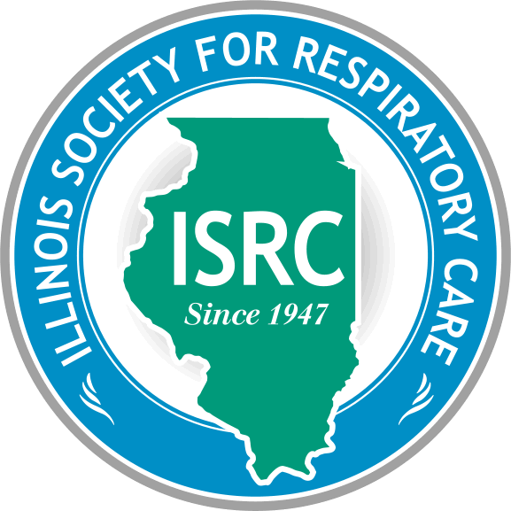
ILLINOIS SOCIETY FOR RESPIRATORY CARE

Affiliate of AARC
Administrative Office: P.O. Box 10261-Springfield, IL 62791
(217) 522-5558- FAX (217) 522-5557

Board of Directors
Third Quarter Meeting Minutes
January 18, 2023

- Steve Mosakowski called the meeting to order.

- Roll call via Secretary Jacki Moss

President – Steve Mosakowski | P | Chapter 1 Chair – John Sloam | A | Chapter 1 Rep - Open | _
President Elect – Anne Geistkemper | P | Chapter 2 Chair – Katie Dugan | P | Chapter 2 Rep – Sara Murphy | P
VP– Midge Seim | P | Chapter 3 Chair – Sarah Higar | A | Chapter 3 Rep - Open | _
Secretary – Jacki Moss | P | Chapter 4 Chair – Aaron Brace | A | Chapter 4 Rep – Open | _
Treasurer – Gina Hoots | P | Chapter 5 Chair – Lori Badgley | P | Chapter 5 Rep – Kristin King | P
Delegate – Lexi Caraway | P | Chapter 6 Chair – Debbie Booton | E | Chapter 6 Rep – Open | _
Alt. Delegate – Molly Marin | P | Administrator - Maureen Mulhall | P | Lobbyist – Matt Maloney | P
P=Present A=Absent E=Excused (10 need to be present if all positions are filled to make a quorum)
A quorum is present.
- Introduction/Induction of any new BOD members –
None

- Welcome Guests, Recognize and Kudos
Brian Lawlor
Kudos/ In memory of:
- Steve’s father in-law worked for Timemeter/Bird and worked in “Inhalation therapy” who just passed away
- Gina Hoots attended the BRPT Leadership to work on the exam matrix, positive experience
- Anne, Steve, and Lisa Zaenger met with IDFPR to express concerns, potential improvements
- Lori is appreciative to Midge, Kristin, and Gina for their help in the development of the Chapter 5 conference
- Second Quarter BOD meeting minutes approved

- Treasurer’s Report – Gina Hoots
- Balances are Checking account - $3,144.83, Credit card balance - $305, Rewards - $1,183.60
- AARC recommends the Treasurer be bonded
- ISRC is up for Financial Reporting and Review with CoARC, currently obtaining all needed documents and there should be no issues.
- Developing a list of all contracts/obligations
- Anything requiring payment needs to go to Lexie, Chair of Budget and Audit
- Developing an Invoice/Cost sheet

- Delegates report – Alternate Delegate – Molly
- Credentialing and Officiary needs to be updated and sent in by Feb. 3
- Profit sharing requirement is being completed and will be due Jan. 31st.
- Financial report is due March 31

- Acceptance of Treasure and Delegates Reports - approved

- Council Reports
Executive Council – Steve Mosakowski, ISRC President
- Administrative report – Maureen, ISRC Administrator
- There is a realignment in the General Assembly with the swearing in of new members
- Changes at the Professional Regulations – IDPR has appointed Office of Innovation which hopefully results in improvement in Licensure. Two prong process – money is allocated AND Governor must spend the money
- Disciplinary reports have occurred due to inactive license, not obtaining appropriate number of continuing education credits, not paying child support, and not paying taxes. Keep these up to date so you can continue to practice.
- All employers must allow 5 paid days’ time off (bereavement, care taker)
- Legislative report – Matt Maloney, ISRC Lobbyist
- First 10 days have been lame duck session. Usually this is a time of not getting much done. This time though they have been busy – assault weapons ban, reproductive health, budget revisions,
- House has 21 new members, Senate has 10 new members so there has been a lot of turnover (15%)
- Bob Morgan has been named the Chair of the Healthcare License Committee
- Encourages us all to visit ILGA.gov, tab on lower left “Legislative lookup” , begin dialogue, introduce yourself, let them know what your professions is. Most new legislators have no healthcare knowledge.
- HB 240 – Delays penalties to nursing homes for shortages in staffing
- AARC PACT – Lisa Zaenger, AARC PACT Chair
- A few new people
- Only 17 districts due to redrawing of districts
- Delays in getting committees setup
- Putting the 2023 plan together
- Working on a report to place on the website
- Sept – trip to DC which will be the first in-person meeting since the pandemic
- Website update – Anne Geistkemper, President Elect
- Gaps due to changing websites are being identified
- A donation tab is being added
- Imagery changes have been made
- Calendar has been edited – now a running list rather than a calendar view. Can “Open Calendar” for that view.
- Steve is working on a “President’s” message video
- Comparison being made between using two different avenues for conference registration to determine the best method to utilize
- Summit Award – Lexi Caraway
- Currently working on process of obtaining information
- Executive Committee – Steve Mosakowski, ISRC President
- Nothing at this time
Governmental Affairs Council -
- Nominations and Elections – Lexi Caraway, Chairperson
- Nothing at this time
- IDFPR visit update – Anne Geistkemper, President elect
- Anne, Steve, and Lisa Z went to the IDFPR and met with Secretary Treto to discuss current issues. Great discussion, great collaboration, planning on future dialog
- They have received funding to update their system
Fiscal Responsibility Council – Gina Hoots, Treasurer
- Budget and Audit – Lexi Caraway, Chairperson
- No update
Professional Development Council – Midge – Vice President
- Education/students – open
- Program – State Conference – Jacki Moss, Molly Martin
- Tentative dates May 27 and 28. Meet tomorrow to work on more details
- Will involve students in the process, introduction of speakers
- Membership – Midge Seim, Chairperson
- 1,002 members of which 118 are student members, let’s encourage them to continue to be members after graduation
- Will add recruitment piece to website

- Strategic Communication Council
- Publications/Social Media – Lexi Caraway
- Public relations –
- Chapter Chairs
Chapter 2 is having a Lunch & Learn at the end of Jan. end of February they are having a full day Preceptor conference, March will have another lunch & learn. Planning on a full day Critical Care conference later in the year
Chapter 5 – March 23, full day in-person conference
Chapter 6 – Feb 15 full day in-person and virtual conference
- Strategic Planning

- Acceptance of Council Reports – approved

- Old Business
- APRT update – Steve Mosakowski
- VA system in Baltimore has a APRT position in open
- Dr Vines will be getting this moving with the formation of new committees
- Brady Scott will be developing the curriculum as a Doctorate in Health Science
- New Business
- Ad space on website – Anne Geistkemper
- Guidelines are being developed with various packages
- Proposing a website committee
- Developing RT programs in the area
- Joliet, Triton, Harper, and Elgin are developing AAS program
- STLCC is adding a bachelor’s program

- Future meeting
- Executive Council – Wed. Feb. 22, 2023, 5:30

- Adjournment

